PH126 Logic I Lecture 8
Lecturer: s.butterfill@warwick.ac.uk

Proofs of the Day
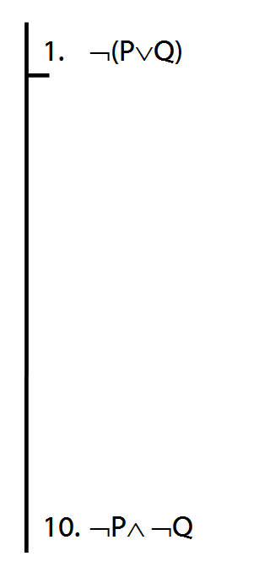
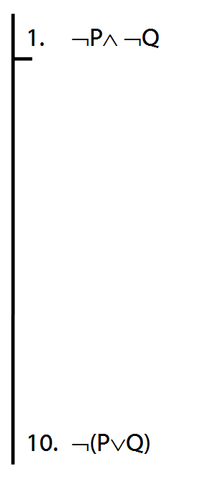
Proof example
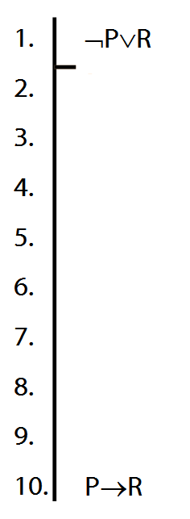

Truth table for →
Assuming that the rules of Fitch are such that it is impossible to prove an argument which is not logically valid, the truth-table for → is fixed if we accept →Elim and →Intro.
How do the rules of proof for → fix its truth table?
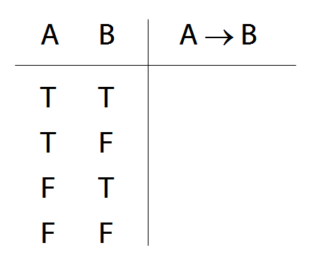
How to determine the truth of sentences involving ∀
1. Give every object a name.
2. For each name in turn, create a new sentence like this: delete the quantifier and replace all instances of the variable it binds with that name
3. If ALL of the new sentences are true, so is the original.
What not to confuse
∃x ( Square(x) ∧ Blue(x)) vs.
∃x Square(x) ∧ ∃x Blue(x)
∀x ( Square(x) → Blue(x) ) vs.
∀x Square(x) → ∀x Blue(x)
¬(P∨Q) vs. ¬P∨¬Q
¬(P∧Q) vs. ¬P∧¬Q
¬ (P→Q) vs. P→¬Q
Exercises 04
For your fifth seminar
Not for fast groups
(Bit more than usual this week because reading week gives you two weeks to complete these)
3.14–15 (counterexamples)
6.8 (proof)
6.24–7 (proof)

7.1–2, *7.3–6 (truthtables)
8.1 (conditionals; yes/no answers are ok)
8.17–19, *8.20–23
9.1 odd nos only (quantifiers)
9.2 even nos only (quantifiers)
9.4–5, 9.8–10, 9.12 (quantifiers)

